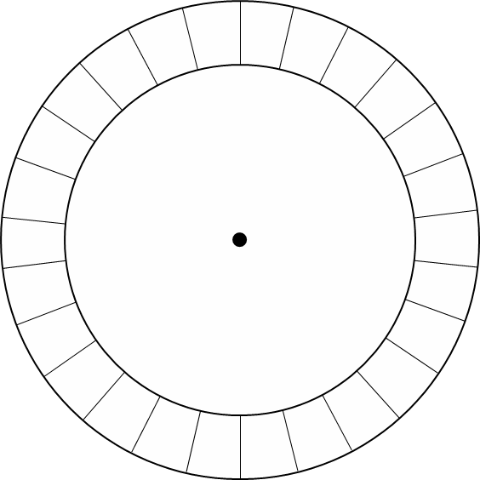Steps:

1. Carefully cut out both circles. The larger circle is for the plaintext. The smaller circle is for the ciphertext.
2. Write the alphabet in one color around the larger circle.
3. Write the alphabet in a different color around the smaller circle
4. Fix the smaller circle to the larger circle at the small dot using a paper fastener.
5. Remember:

**Encryption: larger circle to smaller circle Decryption: smaller circle to larger circle**

